实验三. 频域图像增强技术
- 实验目的
了解频率域图像处理的原理和深刻意义，理解二维谱图像内容的含义，掌握二维Fourier变换和常用的频域图像增强方法。理解频率域图像增强与对应的空域图像技术之间的联系，及各自的优缺点，理解频域滤波器设计作为空域滤波模板设计的指导作用。
- 实验内容
  - 给定一幅图象，画出其谱分布的平面图像，并对谱图像内容进行说明。
  - 频率域高通和低通滤波器设计，并以各种视图（立体图、平面视图、截面图）显示。
  - 给出一幅房屋图象，用高通滤波的方法求其边缘。
- 知识要点及参考程序
- 二维离散傅里叶变换对
let the size of image f(x,y) is (M, N):
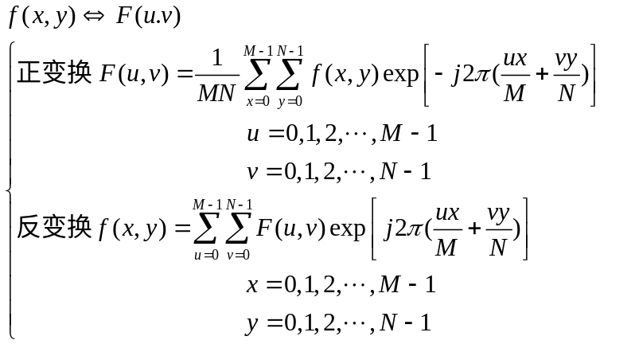important properties:
- conjugate symmetric(if f(x, y) is real)
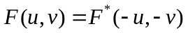
- periodicity
needs for center-shifting in the frequency domain of two dimension (is also called the centering of transform):
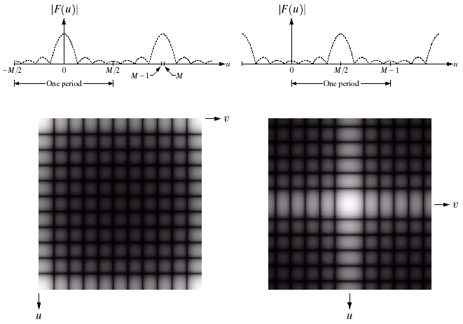
fig.1
method for shifting the origin of the FT to the center (M/2, N/2: relative to mathematical expression, where u and v run from 0 to M-1 and N-1, respectively) of frequency rectangle:
multiplying f(x, y) by (-1)^{x+y} prior to computing the Fourier transform.
- Computation and visualization of 2-D DFT in matlab
2-D FFT and visual analysis of the Fourier spectrum:
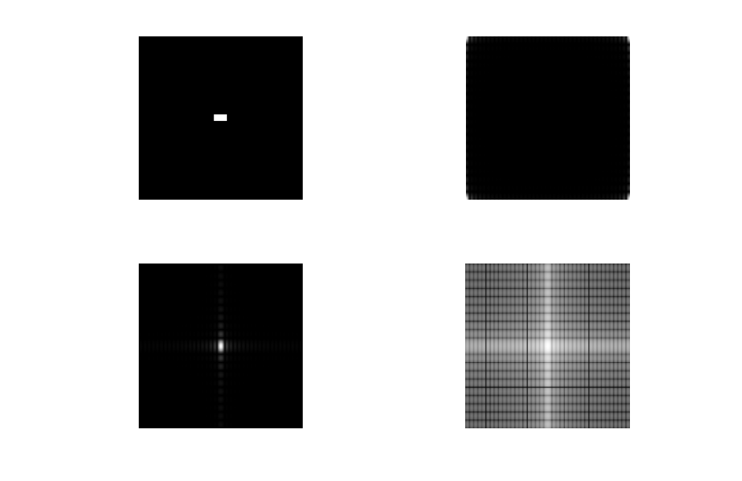
fig.2
Matlab code:
++++++++++++++++++++++++++++++++++++++++++++++++++++++++++++++++++++++
f=imread('Fig0403(a)(image).tif');
f1=double(f); % FFTN on values of class UINT8 is obsolete.Use FFTN(DOUBLE(X)) or FFTN(SINGLE(X)) instead.
F=fft2(f1);
S=abs(F); % computer the Fourier spectrum (equal to the square root of the sum of the squares of the real and imaginary parts)
subplot(221);
imshow(f);
subplot(222);
imshow(S,[]);
Fc=fftshift(F); % shifting the origin of DFT transform to the center of the frequency rectangle
subplot(223);
imshow(abs(Fc),[]);
S2=log(1+abs(Fc)); % gray-scale stretching by a log transformation
subplot(224);imshow(S2,[]);
++++++++++++++++++++++++++++++++++++++++++++++++++++++++++++++++++++++
reverse the centering needed prior to the reverse DFT:
F = ifftshift(Fc);
Inverse Fourier transform:
Real(ifft2(F));
- 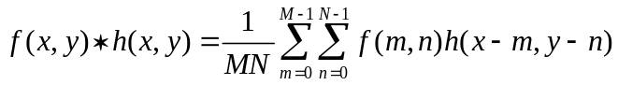Filtering in the frequency domain
Foundation for linear filtering: convolution theorem
Problems need to avoid about frequency filtering: wrapround error, which is caused between adjacent periods by convolving periodic functions with filtering function when the periods are close with respect to the duration of the nonzero parts of the functions. The solution is zero- padding:
Assume that function f(x, y) and h(x, y) are of size A×B and C×D respectively. Two extended (padded) functions, both of size P×Q, is formed by appending zeros to f and h. The basic condition must be met:
P ≥ A+C-1; Q ≥ B+D-1;
To speed-up FFT computation, customarily the P and Q must be even, or are best the powers of 2.
Implementation code:
++++++++++++++++++++++++++++++++++++++++++++++++++++++++++++++++++++++function PQ = paddedsize(AB, CD, PARAM)
%PADDEDSIZE Computes padded sizes useful for FFT-based filtering.
% PQ = PADDEDSIZE(AB), where AB is a two-element size vector,
% computes the two-element size vector PQ = 2*AB.
%
% PQ = PADDEDSIZE(AB, 'PWR2') computes the vector PQ such that
% PQ(1) = PQ(2) = 2^nextpow2(2*m), where m is MAX(AB).
%
% PQ = PADDEDSIZE(AB, CD), where AB and CD are two-element size
% vectors, computes the two-element size vector PQ. The elements
% of PQ are the smallest even integers greater than or equal to
% AB + CD - 1.
%
% PQ = PADDEDSIZE(AB, CD, 'PWR2') computes the vector PQ such that
% PQ(1) = PQ(2) = 2^nextpow2(2*m), where m is MAX([AB CD]).

if nargin == 1
PQ = 2*AB;
elseif nargin == 2 & ~ischar(CD)
PQ = AB + CD - 1;
PQ = 2 * ceil(PQ / 2);
elseif nargin == 2
m = max(AB); % Maximum dimension.

% Find power-of-2 at least twice m.
P = 2^nextpow2(2*m);
PQ = [P, P];
elseif nargin == 3
m = max([AB CD]); % Maximum dimension.
P = 2^nextpow2(2*m);
PQ = [P, P];
else
error('Wrong number of inputs.')
end
++++++++++++++++++++++++++++++++++++++++++++++++++++++++++++++++++++++
example: comparison the difference between filtering with and without padding:
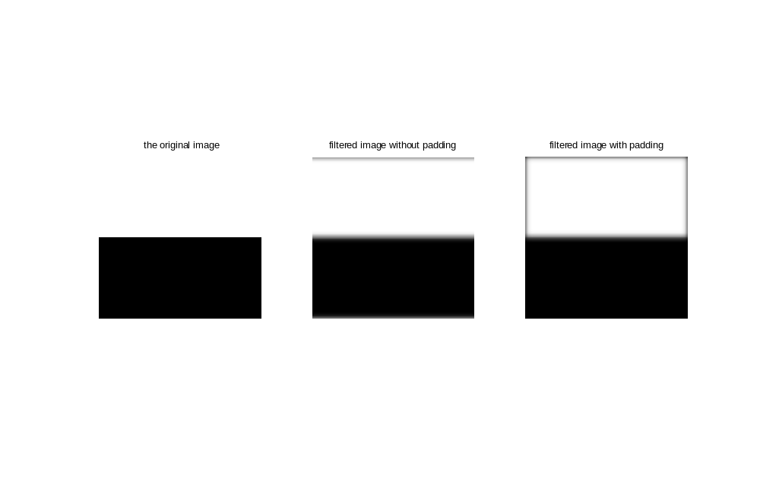
fig.3
code:
+++++++++++++++++++++++++++++++++++++++++++++++++++++++++++++++++++++
f=imread('Fig0405(a)(square_original).tif');
[M,N] = size(f);
F = fft2(double(f));
sig = 10;
H = lpfilter('gaussian', M, N, sig); % design a ‘Gaussian’ lowpass filter;
G = H.*F;
g = real(ifft2(G));
subplot(131);imshow(f,[]);
title(' the original image')
subplot(132);imshow(g,[]);
title('filtered image without padding');
PQ=paddedsize(size(f)); % padding the original image
Fp=fft2(f, PQ(1), PQ(2));
Fp=fft2(double(f), PQ(1), PQ(2));
Hp = lpfilter('gaussian',PQ(1), PQ(2), 2*sig); % extend the filter by zero padding
Gp= Hp.*Fp;
gp = real(ifft2(Gp));
gpc = gp(1:size(f,1), 1:size(f,2)); % truncate the filtered image to make its size the same as input image
subplot(133);imshow(gpc,[]);
title('filtered image with padding');
+++++++++++++++++++++++++++++++++++++++++++++++++++++++++++++++++++++
reason analysis:

fig.4 period extension and zero padding
The above example of lowpass filtering can also be implementation directly in the spatial domain:
f=imread('Fig0405(a)(square_original).tif');
h=fspecial('gaussian',15,7);
gs = imfilter(f,h);
The result is same as that of fig.3(c) completely.

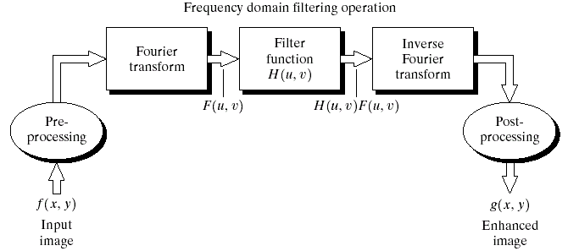
The basic steps for filtering in the frequency domain.

All these steps uniformly can be implemented by the following codes:
++++++++++++++++++++++++++++++++++++++++++++++++++++++++++++++++++++++
function g = dftfilt(f, H)
%DFTFILT Performs frequency domain filtering.
% G = DFTFILT(F, H) filters F in the frequency domain using the
% filter transfer function H. The output, G, is the filtered
% image, which has the same size as F. DFTFILT automatically pads
% F to be the same size as H. Function PADDEDSIZE can be used to
% determine an appropriate size for H.
%
% DFTFILT assumes that F is real and that H is a real, uncentered
% circularly-symmetric filter function.

% Obtain the FFT of the padded input.
F = fft2(f, size(H, 1), size(H, 2));

% Perform filtering.
g = real(ifft2(H.*F));

% Crop to original size.
g = g(1:size(f, 1), 1:size(f, 2));
- Convert spatial filters into equivalent frequency filters. (only FIR filters be considered)
H = freqz2(h, R, C);
Comparison the results of filtering f in the spatial domain with the Sobel mask against the result obtained by performing the equivalent process in the frequency domain.
% show the Fourier spectrum of original image
f = imread('Fig0409(a)(bld).tif');
F = fft2(double(f));
S = fftshift(log(1+abs(F)));
S = gscale(S);
subplot(121);imshow(f);
title('the original image');
subplot(122);imshow(S);
title('the Fourier spectrum after scaled');
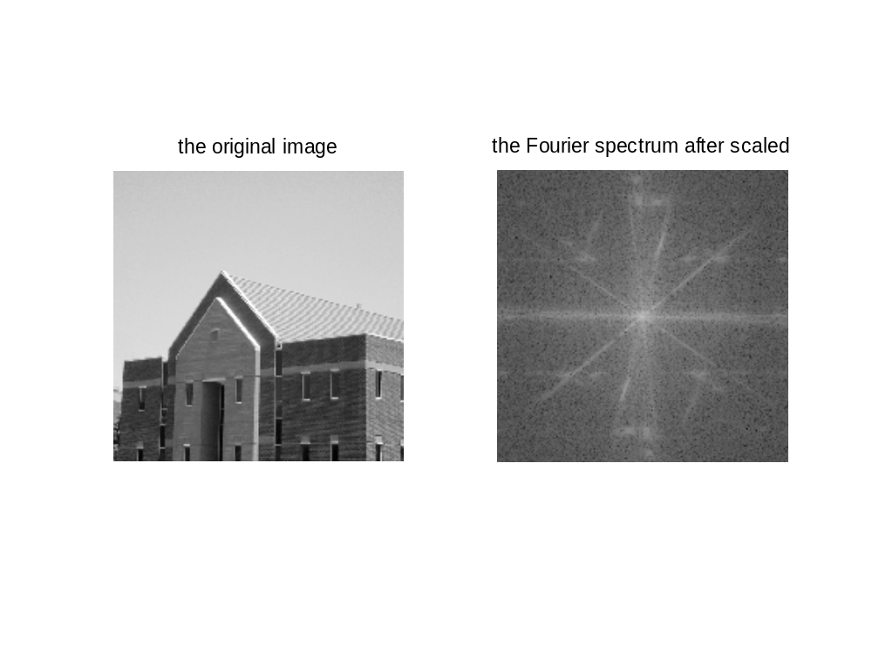
% generate the corresponding filter in spatial and frequency domain
h = fspecial('sobel')'; %generate the vertical Sobel mask
PQ = paddedsize(size(f));
H = freqz2(h, PQ(1), PQ(2)); % generate the equivalent object of Sobel operator in frequency domain
H1 = ifftshift(H); % shift the origin of frequency filter to top-left of frequency rectangle
figure;
subplot(221);
mesh(abs(H(1:20:end, 1:20:end)));
axis off;
title('(a)the perspective plot of corresponding frequency filter');
subplot(222);
mesh(abs(H1(1:20:end, 1:20:end)));
axis off;
title('(b)the frequency filter with its origin located at the top-left of frequency rectangle');
subplot(223);
imshow(abs(H),[]);
title('the image form of figure(a)');
subplot(224);
imshow(abs(H1),[]);
title('the image form of figure(b)');
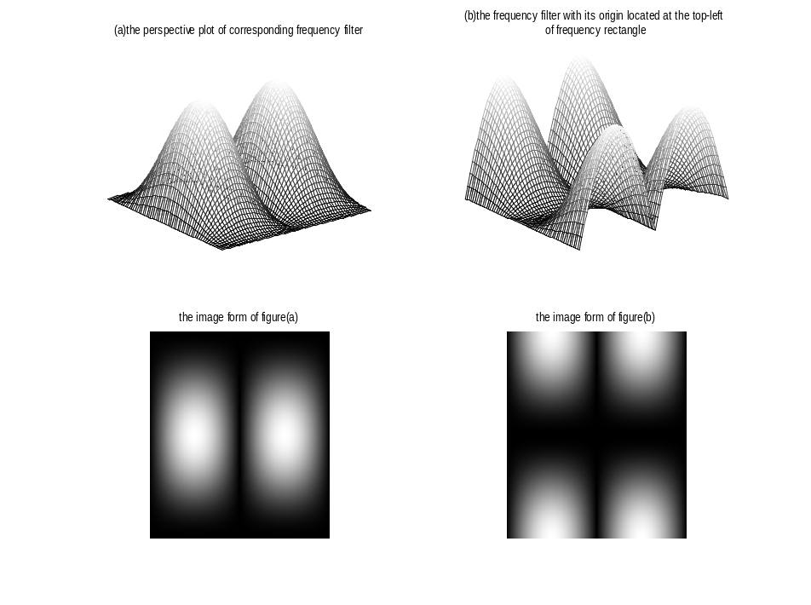

% generate the filtered image in the spatial and frequency domain, respectively
gs = imfilter(double(f), h);
gf = dftfilt(f, H1);
figure;
subplot(221);imshow(gs, []);
title(' the filtered image in the spatial domain')
subplot(222);imshow(gf, []);
title(' the filtered image in the frequency domain')% note the gray tonality in this two images due to the negative value of gs and gf.

% show the absolute value of the two response gs and gf, which is more
% relevant to the verticle edges of images.
subplot(223);imshow(abs(gs), []);
title(' the absolute value of filtered image (spatial method)');
subplot(224);imshow(abs(gf), []);
title(' the absolute value of filtered image (frequency method))');

% threshold value processing for creating a binary image seen more clearly
figure;
subplot(121);imshow(abs(gs) > 0.2*abs(max(gs(:))));
title('binary image of spatial-filtered image')
subplot(122);imshow(abs(gf) > 0.2*abs(max(gf(:))));
title('binary image of frequency-filtered image')

% compute the result difference of two processing in different domain.
d = abs(gs - gf);
max(d(:))
ans = 4.6896e-013
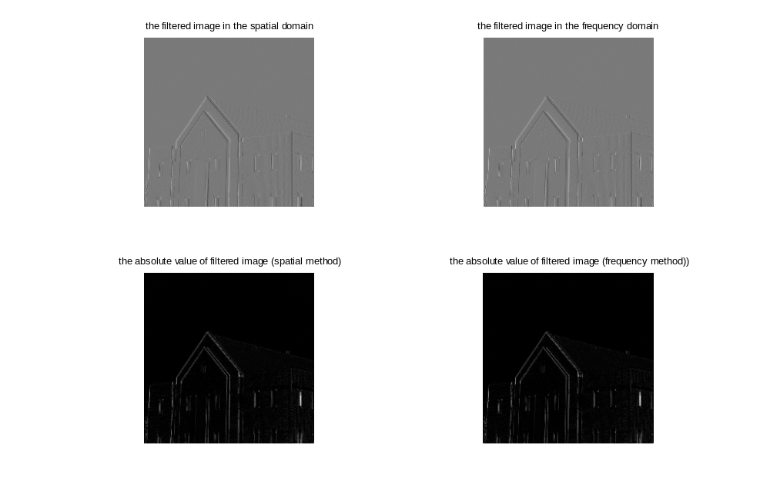

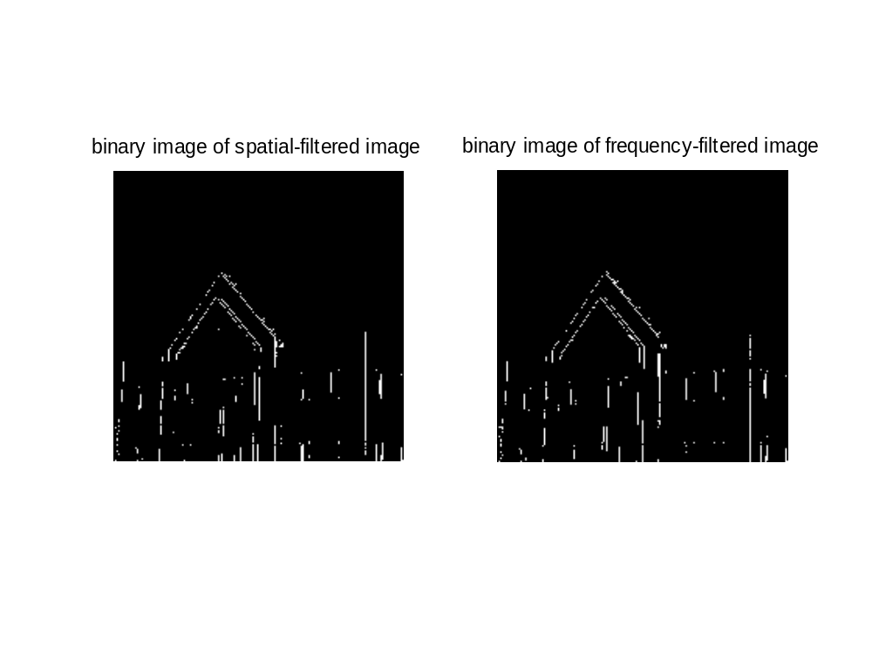
- Generating filters directly in the frequency domain
Focus: circularly symmetric filters that are specified as various functions of distance from the origin of the transform.
A matlab function to generate the necessary meshgrid for use in distance computations and other similar applications.
++++++++++++++++++++++++++++++++++++++++++++++++++++++++++++++++++++++
function [U, V] = dftuv(M, N)
%DFTUV Computes meshgrid frequency matrices.
% [U, V] = DFTUV(M, N) computes meshgrid frequency matrices U and
% V. U and V are useful for computing frequency-domain filter
% functions that can be used with DFTFILT. U and V are both
% M-by-N.

% Set up range of variables.
u = 0:(M - 1);
v = 0:(N - 1);

% Compute the indices for use in meshgrid.
idx = find(u > M/2);
u(idx) = u(idx) - M;
idy = find(v > N/2);
v(idy) = v(idy) - N;

% Compute the meshgrid arrays.
[V, U] = meshgrid(v, u);
++++++++++++++++++++++++++++++++++++++++++++++++++++++++++++++++++++++
various types of low-pass filters:
- 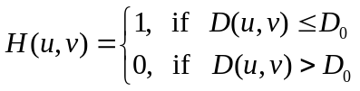ILPF
- BLPF
- 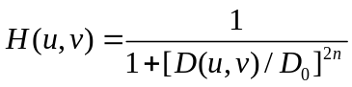GLPF
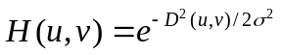The following figures show the three types of low-pass filters of size 500*500, and the cutoff frequency D₀ = 50;
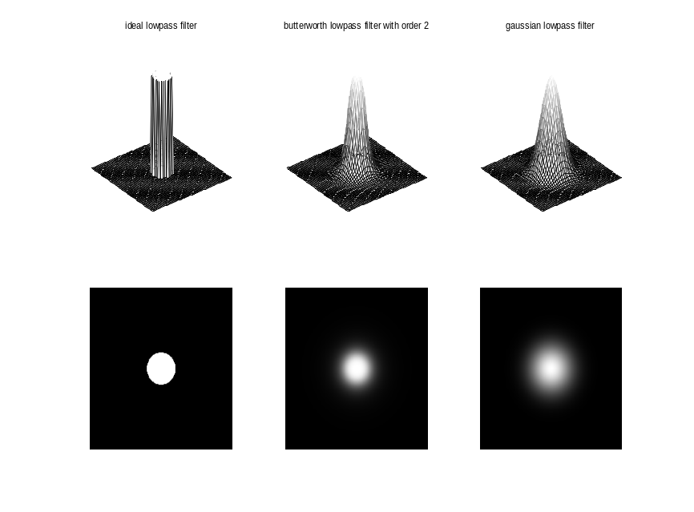
A illustrative example of low-pass filtering, where D₀=5% of the padded image width.
++++++++++++++++++++++++++++++++++++++++++++++++++++++++++++++++++
f = imread('Fig0413(a)(original_test_pattern).tif');
PQ = paddedsize(size(f));
[U, V] = dftuv(PQ(1), PQ(2)); % generating the meshgrid array needed for distance computation
D0 = 0.05*PQ(2);
F = fft2(double(f), PQ(1), PQ(2));
H = exp(-(U.^2+V.^2) / (2*(D0^2)));
g = dftfilt(double(f), H);
subplot(221); imshow(f, []);
title('the original image');
subplot(222); imshow(fftshift(H), []);
title('the original image');
subplot(223); imshow(log(1 + abs(fftshift(F))), []);
title(' the Fourier spectrum of original image');
subplot(224); imshow(g, []);
title('the filtered image by Gaussian lowpass filter');
+++++++++++++++++++++++++++++++++++++++++++++++++++++++++++++++++++++
running results:
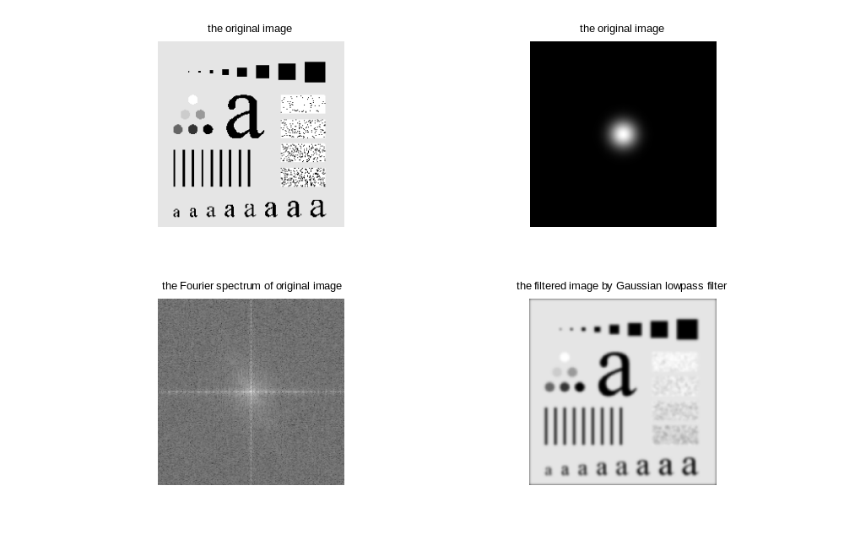
- Sharpening filtering and high-frequency emphasis filtering
High-pass filtering:
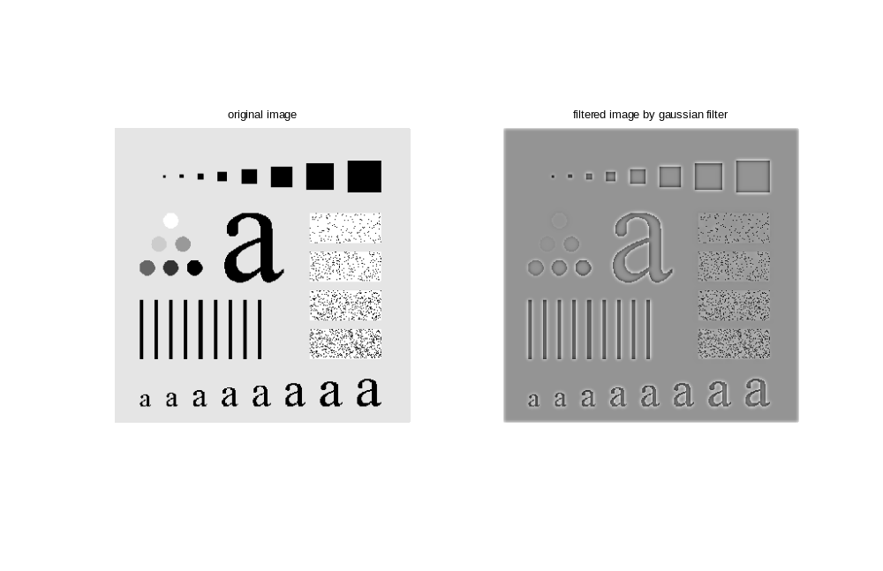
existing problem: high-pass filters zero out the dc term F(0, 0), so lost most of the background tonality present in the original image.
The compensate for this is to add an offset to a high-pass filter and combine with multiplying the filter by a constant greater than 1:
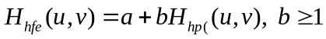
this method is called high-frequency emphasis filtering.
+++++++++++++++++++++++++++++
f = imread('Fig0419(a)(chestXray_original).tif');
PQ = paddedsize(size(f));
D0 = 0.05*PQ(1);
HBW = hpfilter('btw', PQ(1), PQ(2), D0, 2);
H = 0.5 + 2*HBW;
gbw = dftfilt( double(f), HBW);
gbw = gscale(gbw);
gbf = dftfilt(double(f), H);
gbf = gscale(gbf);
subplot(221); imshow(f, []);
title('original bone image');
subplot(222); imshow(gbw, []);
title('high-pass filtering image');
subplot(223); imshow(gbf, []);
title('high-frequncy emphasis image');
ghe = histeq(gbf, 256);
subplot(224); imshow(ghe);
title('histogram equalized image')
+++++++++++++++++++++++++
